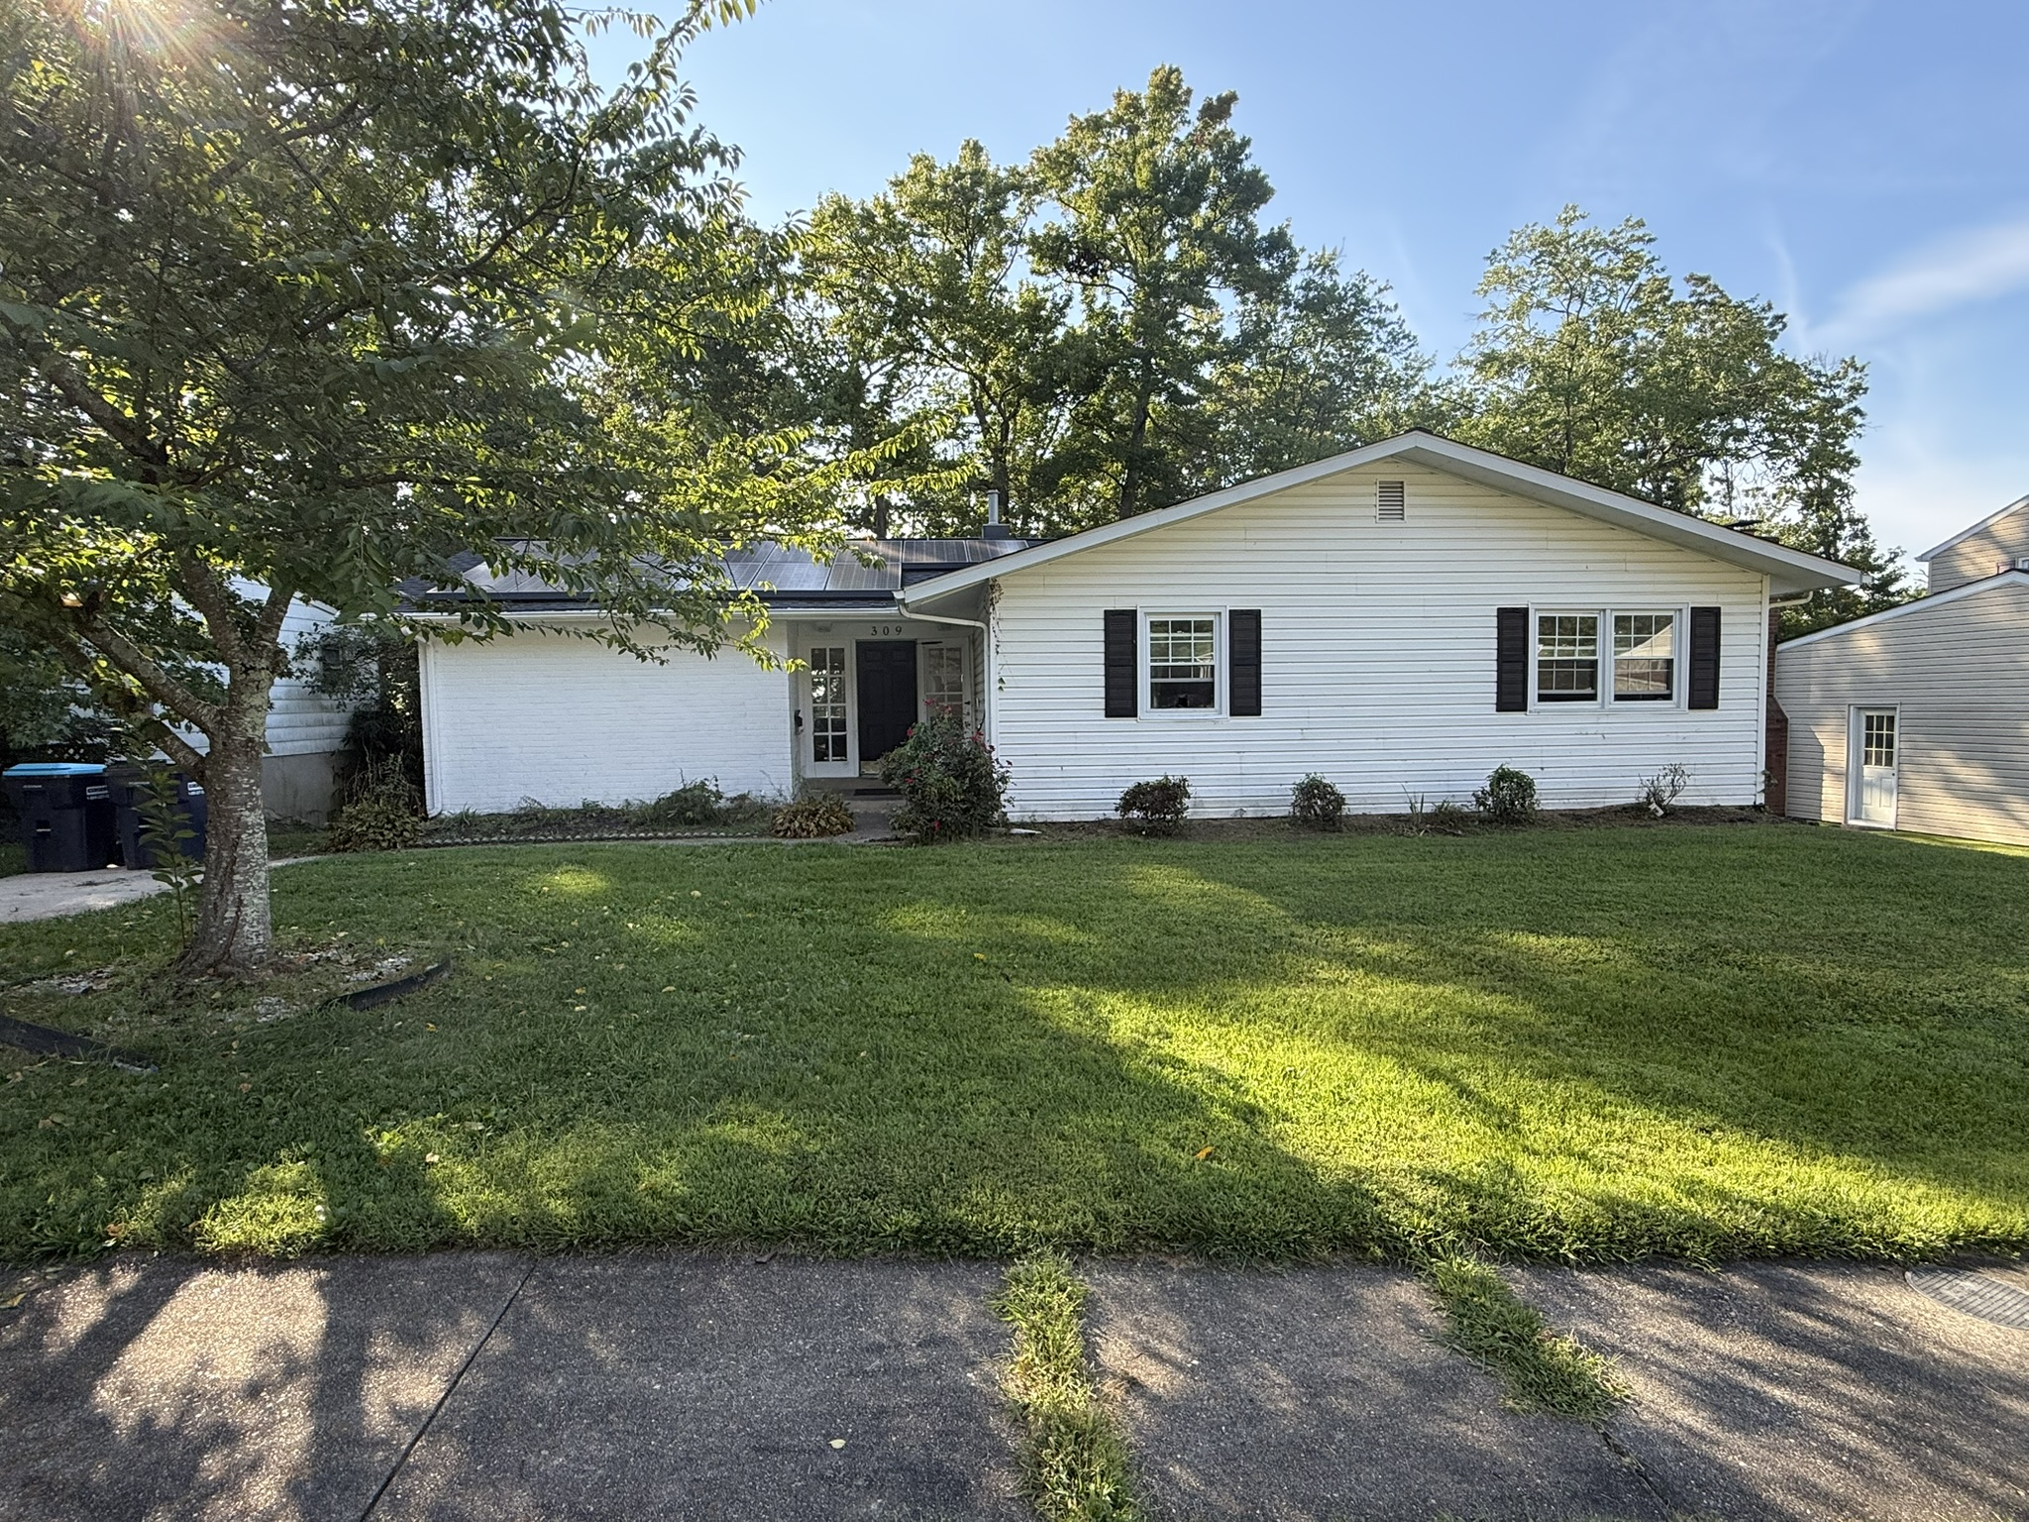

REAL ESTATE
AUCTION

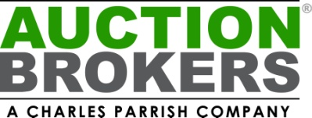

Great opportunity to purchase a 3-bedroom with an extra bonus room in lower level, 2.5-bath (1/2 bath has shower in adjoining room) home in Joppa. Solar panels convey, subject to an existing lease. To be offered by public auction October 24 at 10 AM. List price is suggested opening bid.

5% Buyer Premium added to High Bid. $3000
deposit in certified funds due at sale. 30 day settlement. Broker co-op invited. See Website or MLS for full terms.

SATURDAY OCTOBER 24, 2026 10:00 AM
Call Today to Register

Alan Barnes 410.920.6416
AuctionBrokers.net

309 Tartan Green Ct.
Joppa, MD 21085

